The source code for TSP_bkt(graph), bkt(graph, path, history), sol(graph, path), consistent(graph, path, k), save_sol(graph, path, history) can be found in Walks.py.

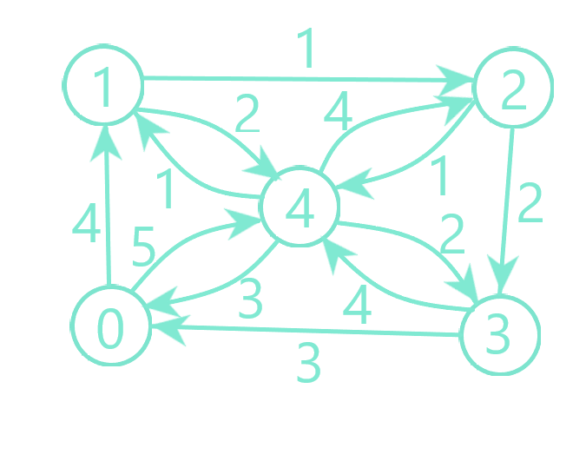

Domain : 0, 1, 2, 3, 4

|  |  |  |
| --- | --- | --- |
| Iteration | Path | History |
| 1 | 0 | - |
| 2 | 0 1 | - |
| 3 | 0 1 2 | - |
| 4 | 0 1 2 3 | - |
| 5 | 0 1 2 3 4 | - |
| 6 | 0 1 2 3 4 0 (cost-14) | 0 1 2 3 4 0 – 14 |
| 7 | 0 1 2 4 | 0 1 2 3 4 0 – 14 |
| 8 | 0 1 2 4 3 | 0 1 2 3 4 0 – 14 |
| 9 | 0 1 2 4 3 0 (cost-11) | 0 1 2 4 3 0 – 11 |
| 10 | 0 1 4 | 0 1 2 4 3 0 – 11 |
| 11 | 0 1 4 2 | 0 1 2 4 3 0 – 11 |
| 12 | 0 1 4 2 3 | 0 1 2 4 3 0 – 11 |
| 13 | 0 1 4 2 3 0 (cost-14) | 0 1 2 4 3 0 – 11 |
| 14 | 0 4 | 0 1 2 4 3 0 – 11 |
| 15 | 0 4 1 | 0 1 2 4 3 0 – 11 |
| 16 | 0 4 1 2 | 0 1 2 4 3 0 – 11 |
| 17 | 0 4 1 2 3 | 0 1 2 4 3 0 – 11 |
| 18 | 0 4 1 2 3 0 (cost-13) | 0 1 2 4 3 0 – 11 |

Output: 0-> 1-> 2-> 4-> 3-> 0 Cost: 11

Example 2:

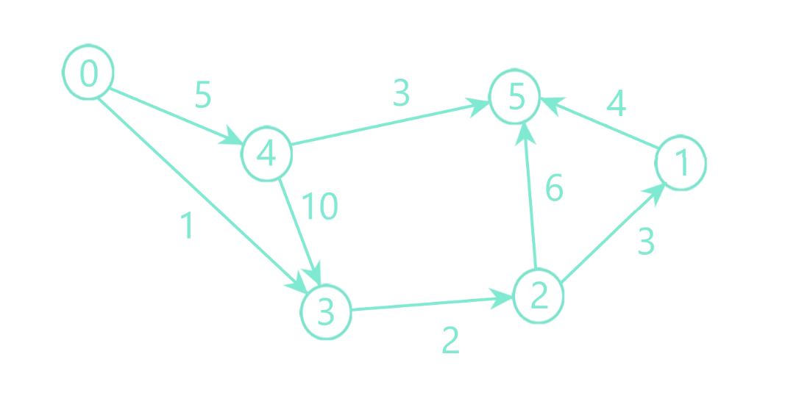

Domain: 0, 1, 2, 3, 4, 5

|  |  |  |
| --- | --- | --- |
| Iteration | Path | History |
| 1 | 0 | - |
| 2 | 0 3 | - |
| 3 | 0 3 2 | - |
| 4 | 0 3 2 1 | - |
| 5 | 0 3 2 1 5 | - |
| 6 | 0 3 2 5 | - |
| 7 | 0 4 | - |
| 8 | 0 4 3 | - |
| 9 | 0 4 3 2 | - |
| 10 | 0 4 3 2 1 | - |
| 11 | 0 4 3 2 1 5 | - |
| 12 | 0 4 3 2 5 | - |
| 13 | 0 4 5 | - |

Output: The graph does not have a Hamiltonian cycle